# **Sigmoid Neuron**

## **Sigmoid Model**

### **Model Part 3**

How does this help when the data is not linearly separable

1. y = 1/(1 + exp(-(wTx + b))
2. Consider the following dataset

|  |  |  |  |
| --- | --- | --- | --- |
|  | Salary in LPA | Family Size | Buys Car? |
| 0 | 11 | 8 | 1 |
| 1 | 20 | 7 | 1 |
| 2 | 4 | 8 | 0 |
| 3 | 8 | 7 | 0 |
| 4 | 11 | 5 | 1 |

1. The dataset is visualised 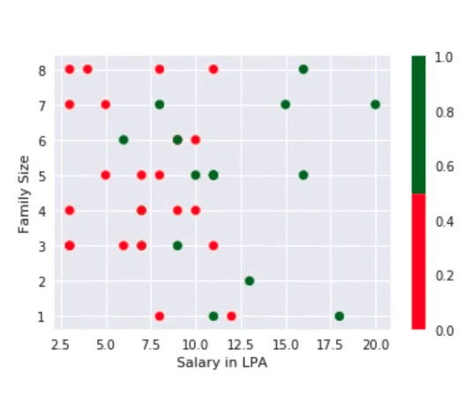
2. Decision Boundary: Perceptron 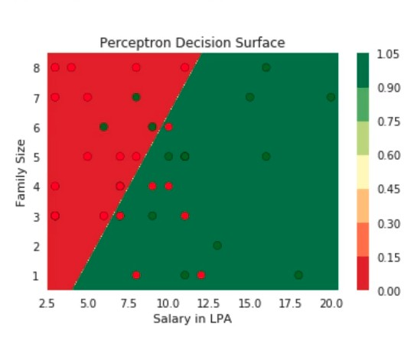
3. Decision boundary: Perceptron with sigmoid. (Not optimised to separate outputs efficiently)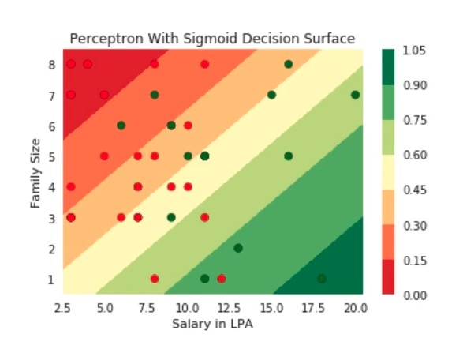
4. Here even the sigmoid function doesn’t effectively separate the outputs.
5. We must play around with different values of w and b to find the best fit
6. This can be done with the learning algorithm